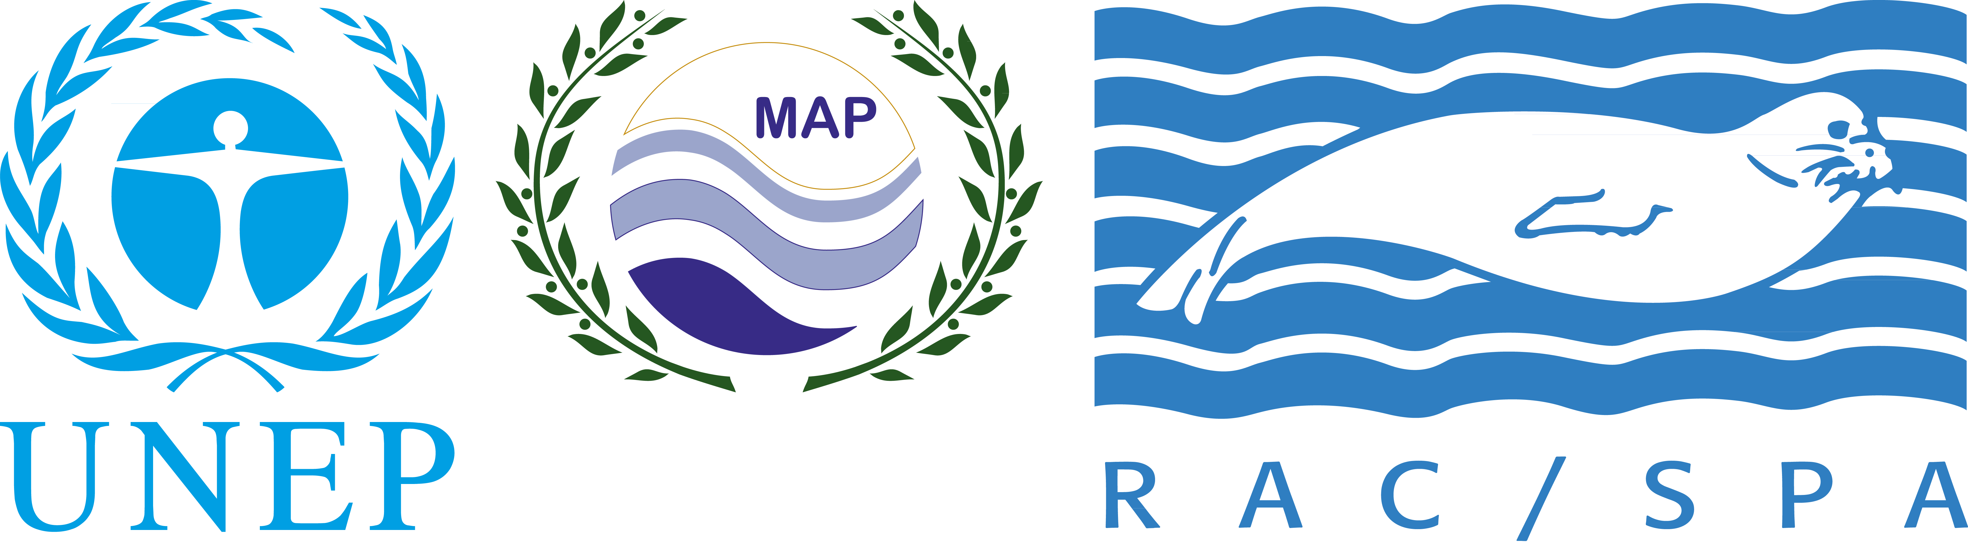

MEDMARAVIS

2nd Symposium on the Conservation of Marine
and Coastal Birds in the Mediterranean

20 to 22 February 2015
Hammamet - TUNISIA

Pre-registration form

Please e-mail the completed form no later than 20 December 2014

Ms. Lobna Ben Nakhla
Email: lobna.bennakhla@rac-spa.org

First Name: |  |  | Last name:
Institution / Organisation: |  |  | Position:
Postal address:
Post code: |  |  | Town:
Country: |  |  | Passport N°:
Email: |  |  | Phone N°: | +
Will you need funding for your attendance? Please tick accordingly:
For international flight: |  |  | For hotel accommodation:

Please note: 1)The organizers have secured some financial resources for the attendance of not self-funded participants. However, we would also like to encourage all participants to source their own funding for the attendance of the symposium, as the available funds will not allow covering expenditure for all participants.
2) Coach transportation from/to Tunis airport will be organized for the afternoon of 19th Feb. and for the morning of 23rd Feb.

Please insert title, authors and abstract of you presentation (not more than 250 words):

